**Today command**

* **Hostname , IfConfig, cat /etc/os-release, Yum install httpd, Yum remove httpd, Yum update httpd, Service httpd start, Service httpd status, Chkconfig httpd on, Chkconfig httpd off, Which, Whoami, Echo, Yum list installed**

**Hostname =** we use hostname to know our machine ip address

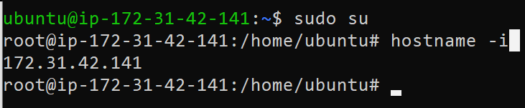

* We use this command to know our machine ip

**root@ip-172-31-42-141:/home/ubuntu#** **hostname –i**

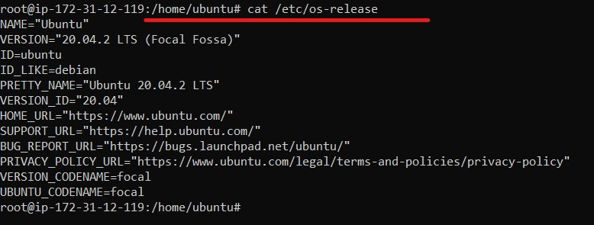

* If we want to check our system Ubuntu version we use this command.

**root@ip-172-31-12-119:/home/ubuntu#** **cat /etc/os-release**